CF Team,

As we begin the semester and the year, we would like to remind you of our email signature standards and share a few changes. We have replaced the Aspen Prize Top 150 icon with the College Choice icon, which illustrates our rankings as No. 17 Best Community College and No. 22 Best Online College in the nation. If the Levy Campus is your home base, please ensure that your signature reflects the new address and telephone number.
A standard, consistent and clean email signature facilitates communications with our constituents: students, colleagues and community members. The signature is designed to maximize contact information while presenting a professional image. Please change your @cf.edu email account to reflect the following format for external and internal messages. Refrain from adding personal messages, artwork, quotes, etc., which distract from your message.

Jane Smith | College of Central Florida (Palatino Linotype, 11 pt, black font)
Title | Department
Building Name, Room ___
3001 S.W. College Road | Ocala, FL 34474-4415 (or Citrus, Levy, Hampton Address)
352-854-2322, ext. ____ | Fax 352-___-____
youremail@cf.edu | www.CF.edu
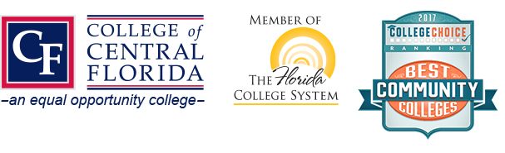
Please Note: Due to Florida's very broad public records law, most written communications to or from college employees regarding college business are public records, available to the public and media upon request. Therefore, this email communication may be subject to public disclosure.

To create a signature:
- Copy an already existing sample signature like above (including logos and disclosure statement).
- In Outlook, go to File, then down to options.
- Go to Mail, then to Signatures.
- Click New, then name your signature.
- Paste the sample signature you copied earlier into this space.
- Update with your information and click and Save and then OK.
- Please note full addresses for other CF locations:

CF Citrus Campus | 3800 S. Lecanto Highway, Lecanto, FL 34461-9026
352-746-6721, ext. ____ | Fax 352-249-1218

CF Levy Campus | 15390 N.W. Highway 19, Chiefland, FL 32626
352-658-4077, ext. ____ | Fax 352-493-9994

CF Hampton Center | 1501 W. Silver Springs Blvd., Ocala, FL 34475-6456
352-873-5881, ext. ____ | Fax 352-873-5887
- If you need assistance, please contact Steve Hill, ext. 1762.

